This week, I write a IIC bus model. The simulation outcome is below.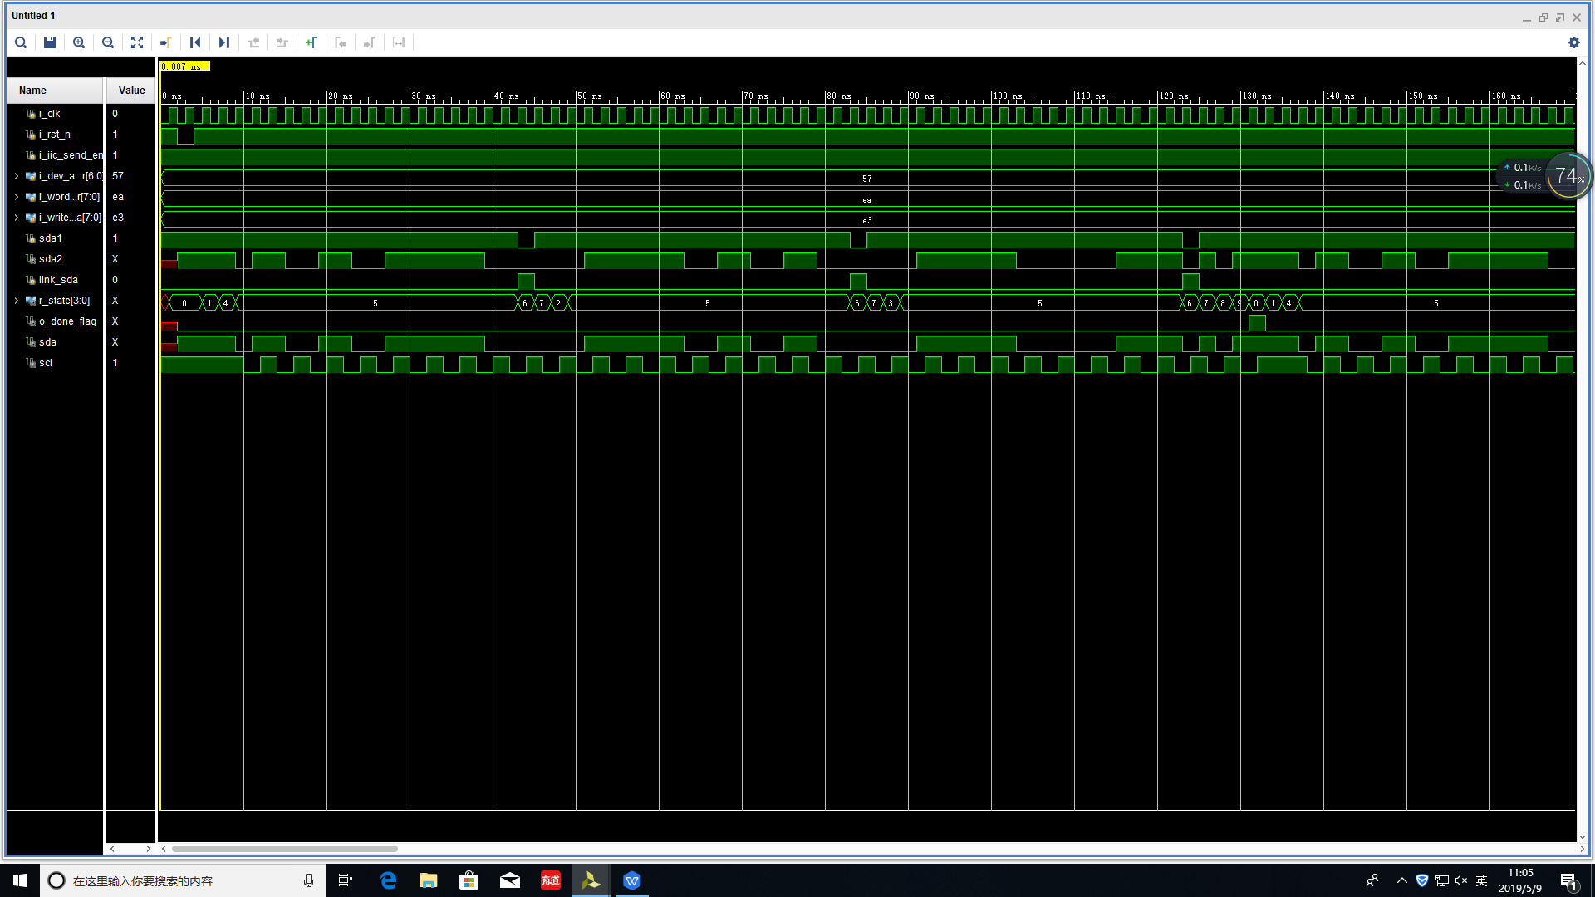

Fig 1:this is the simulation output of IIC_transmitter

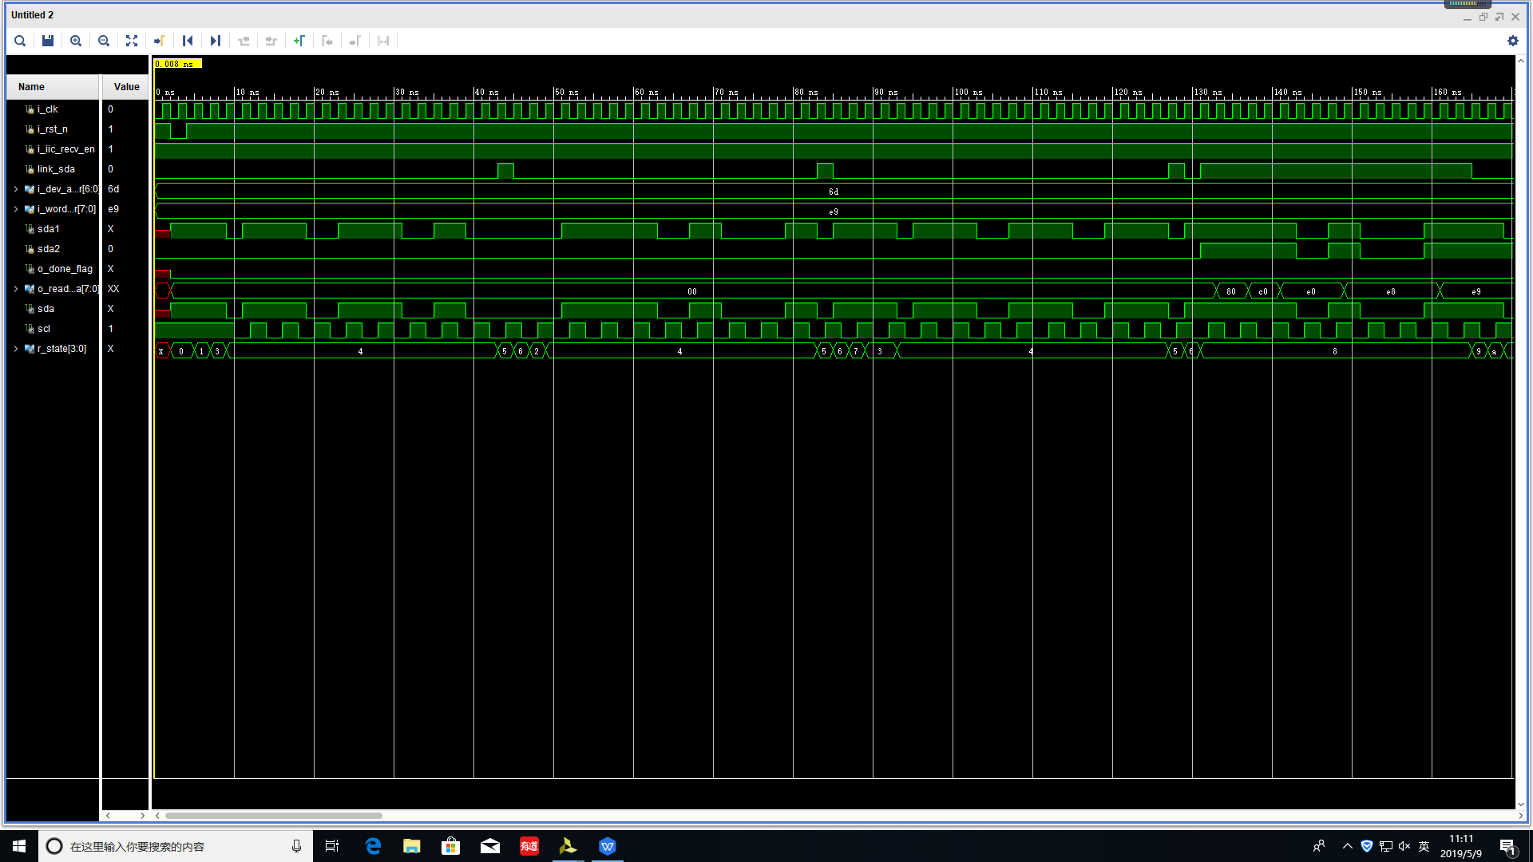

Fig 2:this is the simulation output of the IIC_recv